How to make the Vibration Actuator

Parts Needed

|  |  |  |
| --- | --- | --- |
| Sr No. | Name | Link |
| 1 | Particle Core | [www.Particle.io](http://www.spark.io) |
| 2 | Adafruit Micro Lipo w/MicroUSB Jack - USB LiIon/LiPoly charger | <http://www.adafruit.com/products/1904> |
| 3 | Particlefun 850 mAh Li-Ion Battery | [https://www.Particlefun.com/products/341](https://www.sparkfun.com/products/341) |
| 4 | Vibration Motor | [https://www.Particlefun.com/products/8449](https://www.sparkfun.com/products/8449) |
| 5 | Latching Switch (only for one Actuator) | <http://www.ebay.com/itm/50-Pcs-Latching-Contact-3-Pins-Tactile-Push-Button-Switch-8-5x8-5mm-/321058500210> |

Circuit Diagrams to build Vibration Actuators using Particle Core

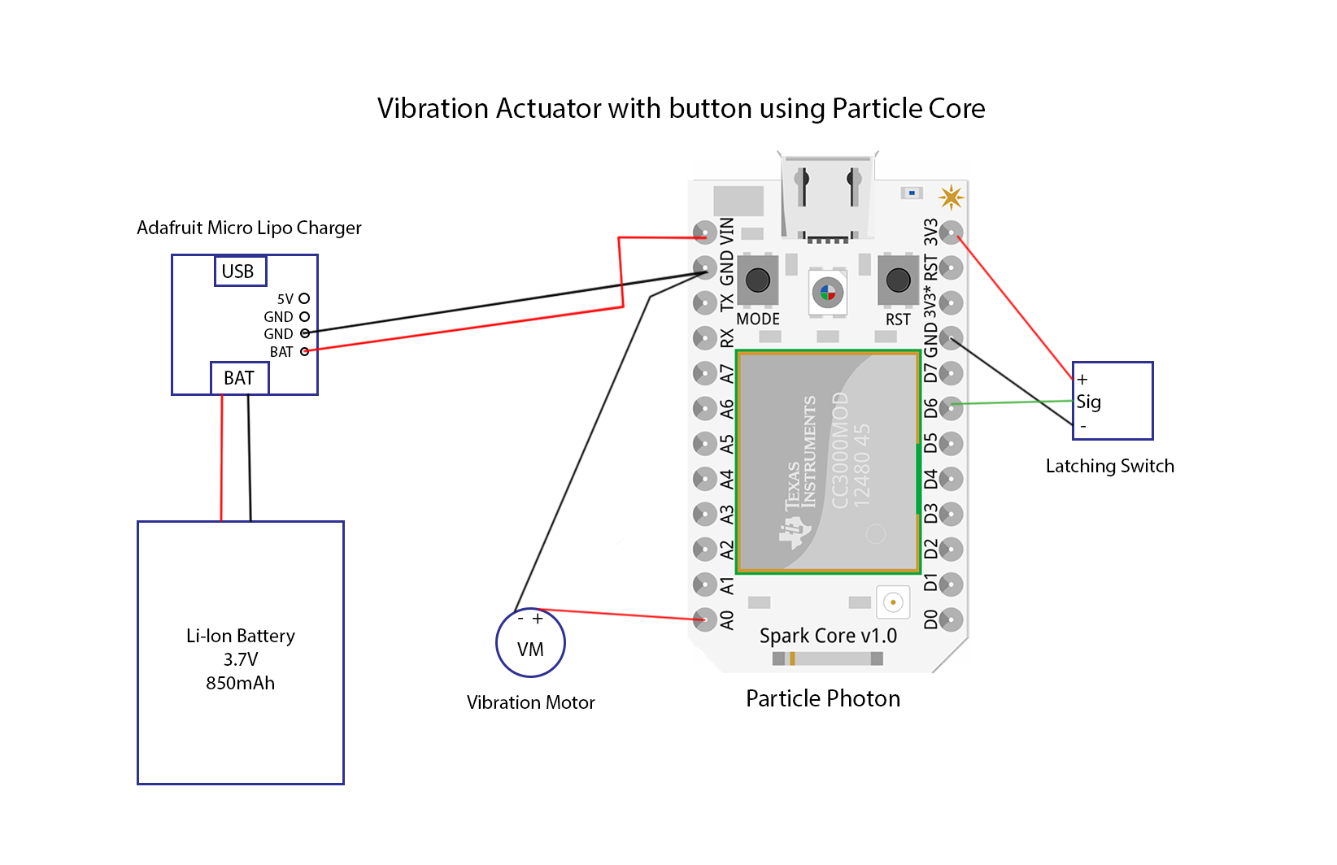

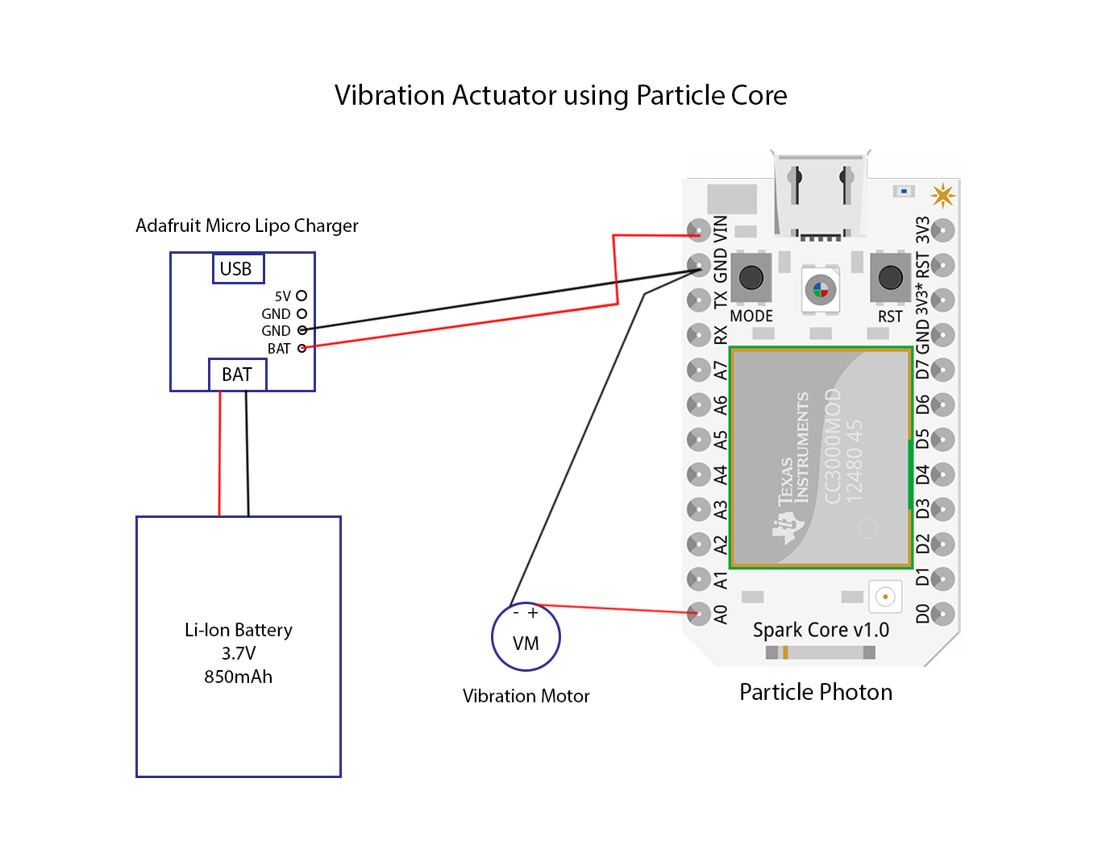

Instructions to build actuators using Particle Core

1. Desolder all the pins on the Particle Cores and take them out.
2. Connect the Battery charger to the Particle Core by connecting the Bat pin to the VIN pin and the GND pin to the GND pin on the Particle Core. Do not connect the battery to the battery charger while soldering short circuits might happen.
3. Solder the 500mA slot on the battery charger. This will Speed up the charging as it allow more current for charging the battery.
4. Connect the red wire (positive) of the vibration motor to the pin A0 of the Particle core and the blue wire (Ground) to the GND pin of the Particle Core.
5. If you are making the actuator with the button, solder the middle pin of the latching switch to the D6 pin of the Particle core. For the other two pins of the latching switch, one can be connected to the 3V3 pin and other can be connected to the GND pin of the Particle core. Reversing these pin connections flips the On/Off positions for the latching switch. The idea is that when the switch is pressed to the “ON” position, it sends a 3V signal to the D6 pin.
6. Once everything is soldered, you can connect the battery to the battery charger and see if the Particle core powers on. This can be confirmed by looking at the light on the Particle core.
7. If you haven’t used a Particle core before, follow the instructions on [http://docs.Particle.io/](http://docs.spark.io/) to learn how to flash the Particle core. Important tip, once you have soldered the Particle core, only power the Particle core using the battery charger. If the battery has no charge you can charge the battery/ power the core by any USB power source by connecting the USB cable to the Micro USB port of the battery charger. If you haven’t soldered the Particle core, then you can use the micro USB connector on the Particle core itself to power the core for flashing new code on it.
8. You can find the code for the Particle core in the package folder. You can use the Cloud API of Particle Core to flash the cores. Once the core is flashed, we are disconnecting it from the cloud, so to reflash the core with any updated code, you have to factory reset the core to update the code on the Particle cores. Once you do a factory reset, you can update the core as mentioned above. To factory reset the Particle core, follow the video <https://www.youtube.com/watch?v=nGBSYyTo5xA> It is highly recommended to play with the Particle core before using it for this project so you get an idea of it’s working.
9. Once the Core is flashed and the core is running without any problems, you can 3d Print the boxes and the lid from the files given in the folder and then put the circuit into the box. It should be assembled as shown in the picture below. In case of the Actuator with the button, you can put the button in the case as will in the slot provided.
10. Put the battery in the box and cover with the lid.

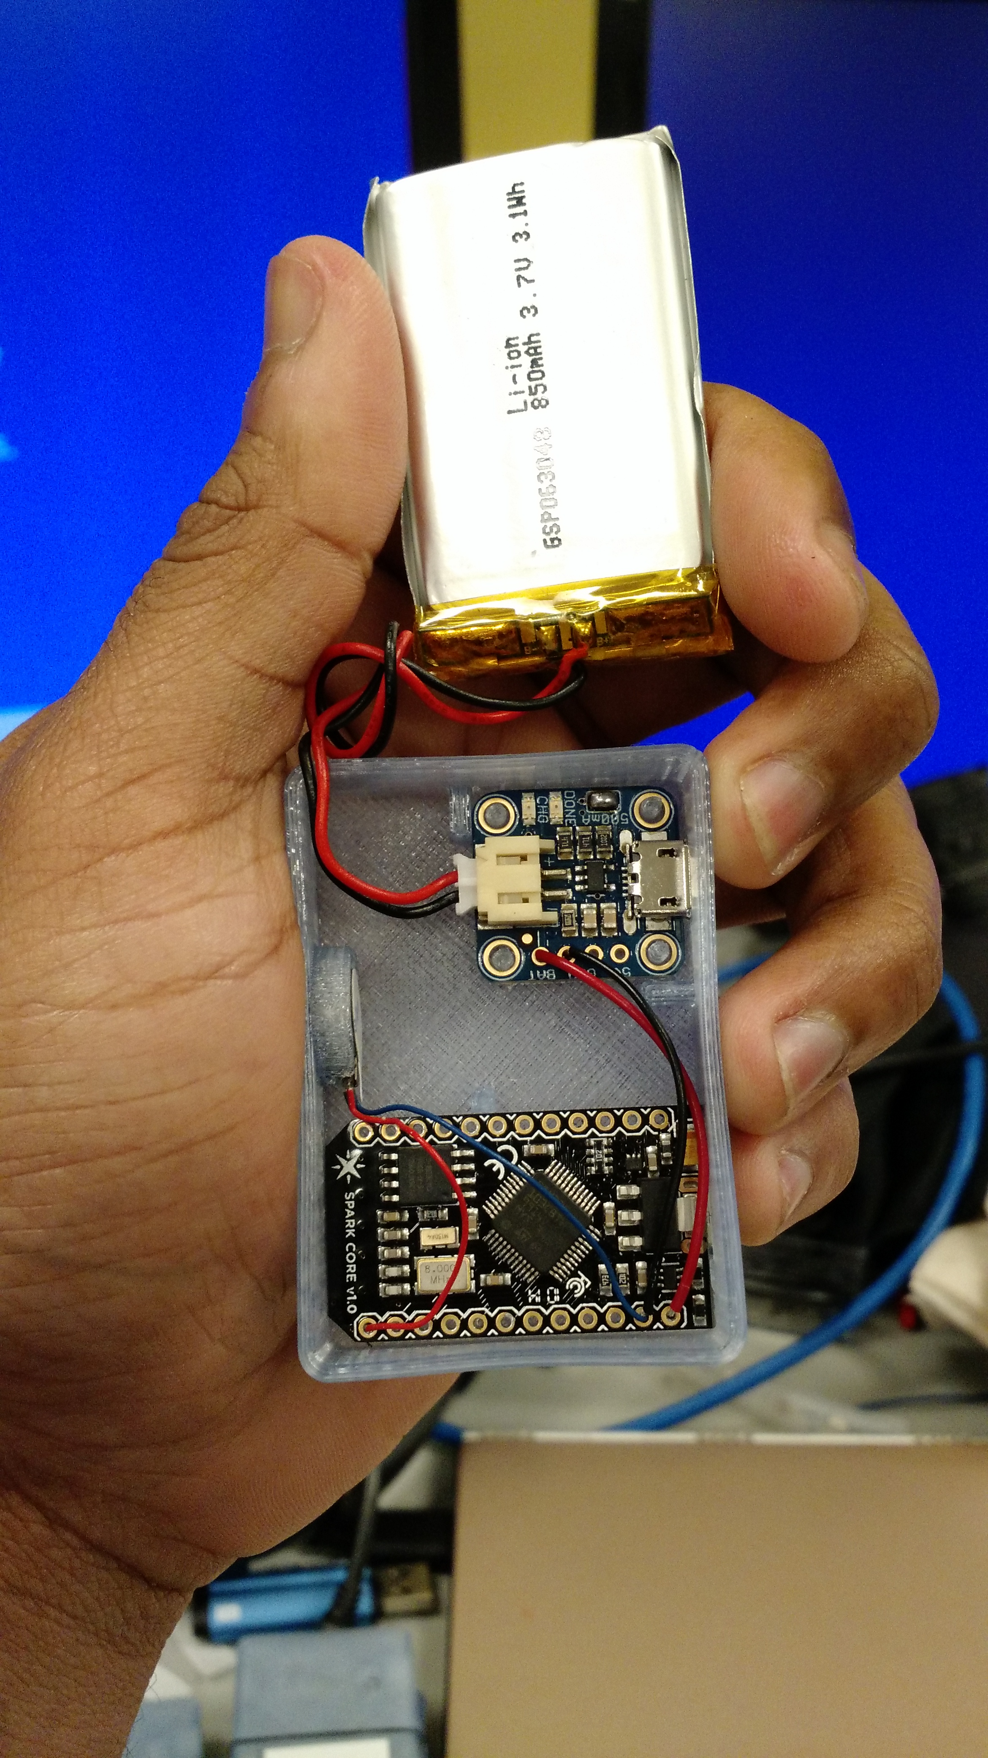

Circuit Diagrams to build Vibration Actuators using Particle Photons

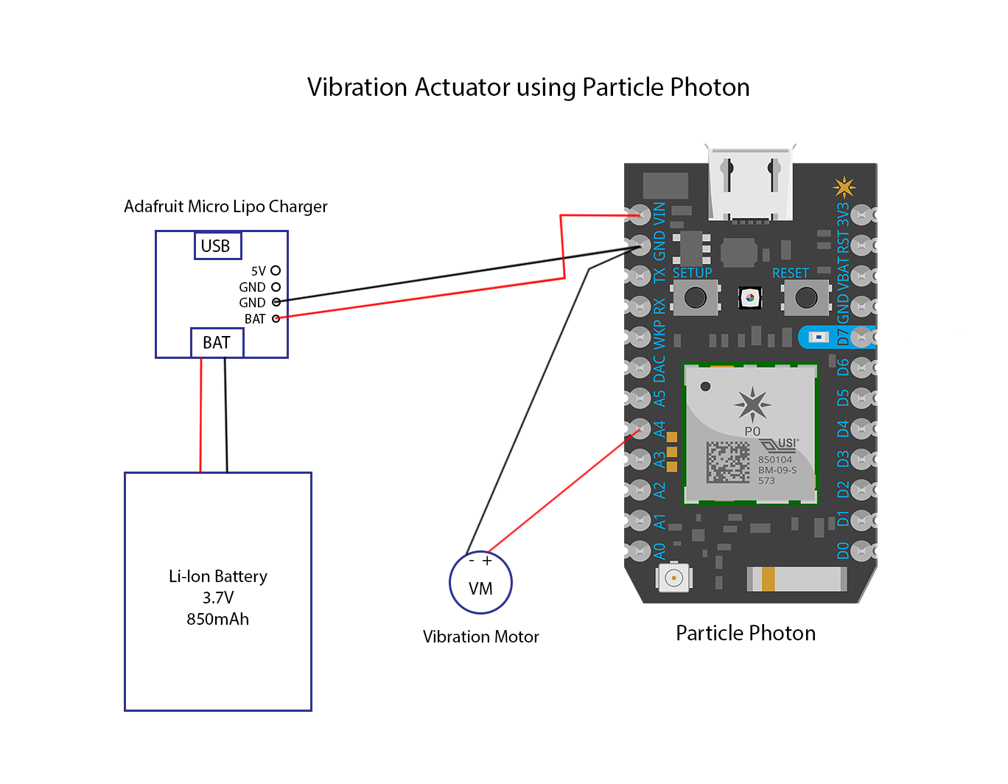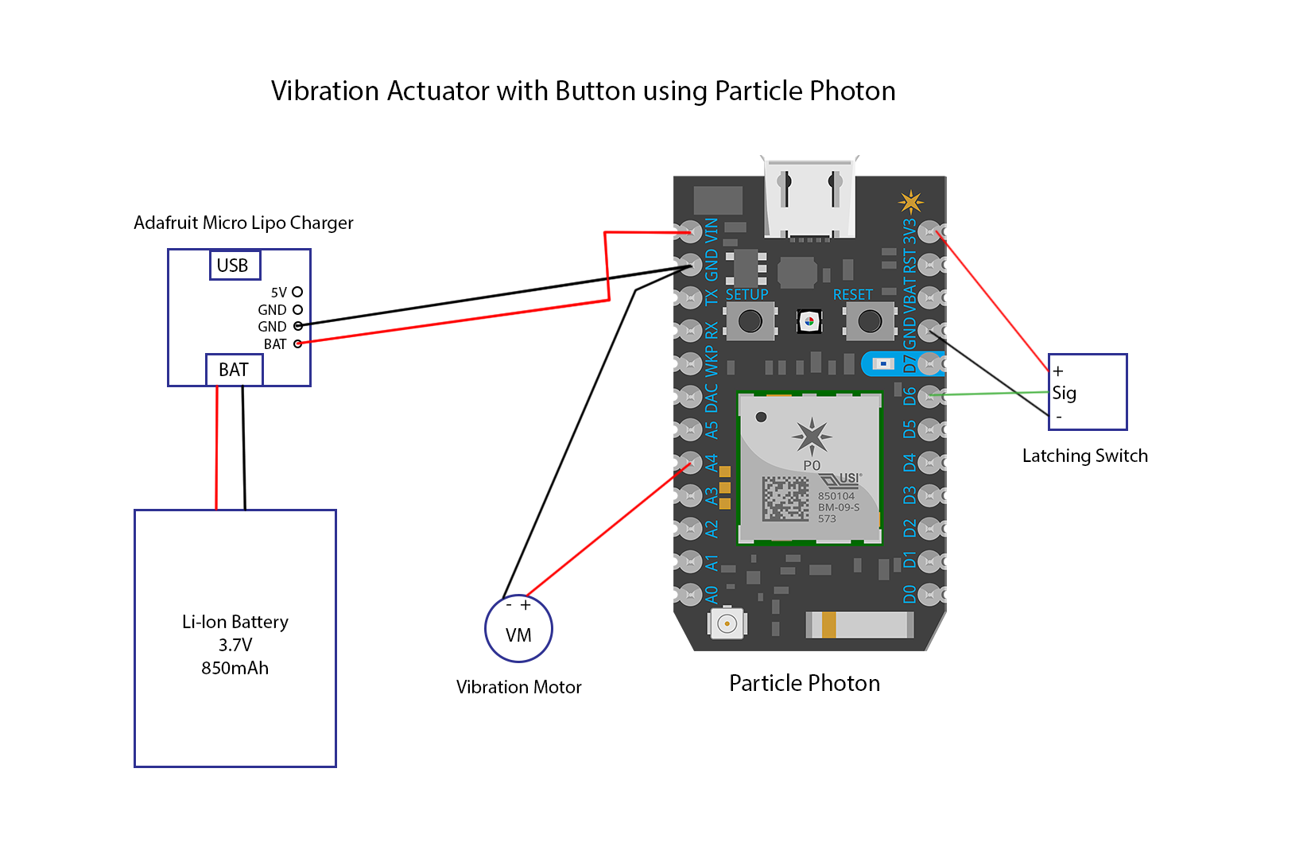

Instructions to build actuators using Particle Photon

1. Desolder all the pins on the Particle Photons and take them out.
2. Connect the Battery charger to the Particle Photon by connecting the Bat pin to the VIN pin and the GND pin to the GND pin on the Particle Photon. Do not connect the battery to the battery charger while soldering short circuits might happen.
3. Solder the 500mA slot on the battery charger. This will Speed up the charging as it allow more current for charging the battery.
4. Connect the red wire (positive) of the vibration motor to the pin A4 of the Particle Photon and the blue wire (Ground) to the GND pin of the Particle Photon.
5. If you are making the actuator with the button, solder the middle pin of the latching switch to the D6 pin of the Particle Photon. For the other two pins of the latching switch, one can be connected to the 3V3 pin and other can be connected to the GND pin of the Particle Photon. Reversing these pin connections flips the On/Off positions for the latching switch. The idea is that when the switch is pressed to the “ON” position, it sends a 3V signal to the D6 pin.
6. Once everything is soldered, you can connect the battery to the battery charger and see if the Particle Photon powers on. This can be confirmed by looking at the light on the Particle Photon.
7. If you haven’t used a Particle Photon before, follow the instructions on [http://docs.Particle.io/](http://docs.spark.io/) to learn how to flash the Particle Photon. Important tip, once you have soldered the Particle Photon, only power the Particle Photon using the battery charger. If the battery has no charge you can charge the battery/ power the Photon by any USB power source by connecting the USB cable to the Micro USB port of the battery charger. If you haven’t soldered the Particle Photon, then you can use the micro USB connector on the Particle Photon itself to power the Photon for flashing new code on it.
8. You can find the code for the Particle Photon in the package folder. You can use the Cloud API of Particle to flash the Photons. Once the photon is flashed, we are disconnecting it from the cloud, so to reflash the photon with any updated code, you have to factory reset the Photon to update the code on the Particle Photon. Once you do a factory reset, you can update the Photon as mentioned above. To factory reset the Particle Photon, follow the instructions on the website [http://docs.Particle.io/](http://docs.spark.io/) It is highly recommended to play with the Particle Photon before using it for this project so you get an idea of it’s working.
9. Once the Photon is flashed and the Photon is running without any problems, you can 3d Print the boxes and the lid from the files given in the folder and then put the circuit into the box. It should be assembled as shown in the picture below (Image is of a Particle Core but it will be same). In case of the Actuator with the button, you can put the button in the case as will in the slot provided.

Put the battery in the box and cover with the lid.

